#### Lab 1: Diode Characteristics

#### Introduction:

The objective of this lab is to analyze diodes, specifically the *pn* junction characteristics of a diode. A *pn* junction is a combination of a *p-type* material, which is an impurity such as Antimony which has free electrons, and an *n-type* material, which is an impurity such as Boron which none. Such a junction, or a diode, has unique properties in an electrical circuit which allow it to either block or allow current to pass through it, depending on the direction. A p-type material, as explained, is more willing to accept electrons carrying charge, and will therefore allow it to pass. An n-type material however is not, and will not allow the charge to pass through. It should be noted that this “forward bias” experienced when charge passes through a diode has about a 0.7 volt bias across the silicon junction. Both a DC and an AC source will be evaluated over the test circuit for this experiment to observe a diode’s behavior in both environments.

#### Bench Parts and Equipment List:

***Components***

|  |  |
| --- | --- |
| * 1kΩ Resistor | * 4001N Diode |

***Equipment***

|  |  |
| --- | --- |
| * Programmable DMM | * DMM and Oscilloscope Probes |
| * Triple Power Supply | * Windows Machine w/ Multisim |
| * DS1102E Digital Oscilloscope | * Function Generator |

**Discussion:**

***Part 1 – Simulating the DC Circuit***

The first step in this lab and subsequent labs will be to construct our test circuits in Multisim to observe the theoretical behavior of such a circuit without varying resistor values or inconsequential smaller internal resistances of certain pieces of equipment, such as a DMM or Triple Power Supply. Below is the constructed circuit for part 1 of the lab:

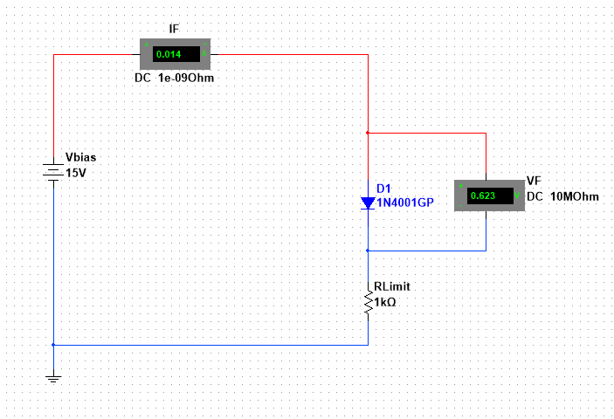

Figure - Part 1 Multisim Series Circuit

Here, measurements were taken with VBias ranging from zero to fifteen volts in one volt increments. An ammeter is connected in series on the anode of the diode to measure the current in the circuit, and a voltmeter is connected in parallel to the diode in order to measure the voltage drop across it. The measurements are available to view in **Table 1**, and a representation of the data is available in **Graph 1** alongside the measurement values for comparison purposes.

**Table 1 - Simulation Data**

|  |  |  |
| --- | --- | --- |
| **Vbias (V)** | **VF (V)** | **IF (A)** |
| 1 | 0.422 | 0.578m |
| 2 | 0.482 | 1.518m |
| 3 | 0.513 | 2.487m |
| 4 | 0.534 | 3.467m |
| 5 | 0.549 | 4.45m |
| 6 | 0.562 | 5.438m |
| 7 | 0.572 | 6.429m |
| 8 | 0.581 | 7.419m |
| 9 | 0.589 | 8.409m |
| 10 | 0.596 | 9.404m |
| 11 | 0.602 | 0.01 |
| 12 | 0.608 | 0.011 |
| 13 | 0.613 | 0.012 |
| 14 | 0.618 | 0.013 |
| 15 | 0.623 | 0.014 |

***Part 2 – Simulating the AC Circuit***

Next, an AC circuit will be constructed to examine the effects of a diode in alternating current environment. The sinusodal AC source will be 10VPP with a 1kHz frequency, and it will be connected in series to a 4001N diode and a 1kΩ resistor.

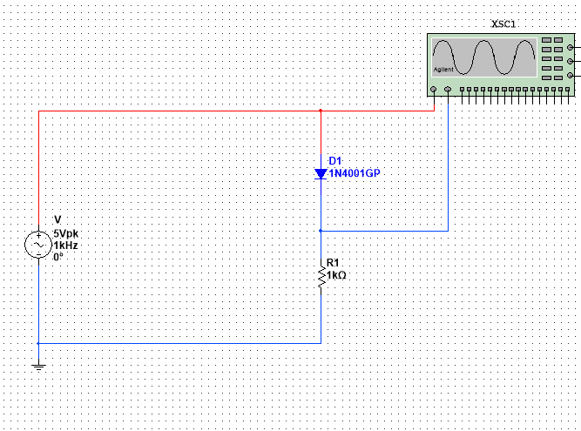

Figure - Part 2 AC Circuit

As shown in **Figure 2**, the Agilent Oscilloscope’s channel 1 is connected to the anode of the diode, and channel 2 to the cathode.

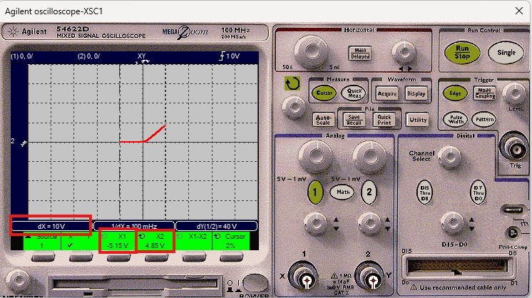

Figure - Oscilloscope Result for AC Circuit

**Figure 3** displays the resulting Oscilloscope result for the circuit found in **Figure 2**. The Δx, Vmin and Vmax are highlighted for observation. It is worth noting that the Oscilloscope is being observed in x-y mode, instead of y-t, this is why our result does not look like two sinusoidal functions.

***Part 3 – Measuring the DC Circuit***

Now we will create the circuit from part 1 [**Figure 1**] on the bench. Remember, we are going to be increasing the VBias voltage in increments of 1 volt from 1 volt to 15 volts, so we will use the Triple Power Supply to provide this voltage to the breadboard.

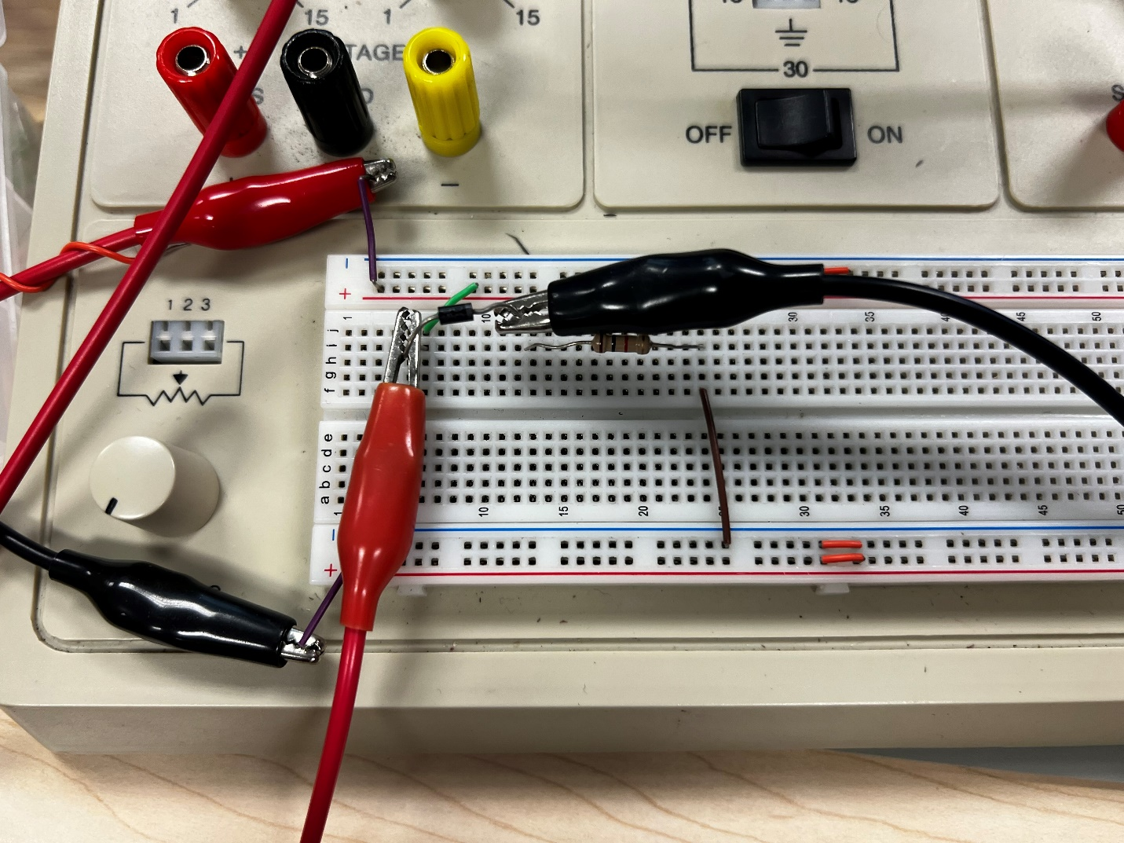

Figure - Constructed DC Circuit on Bench

Note the polarity of the diode, the cathode of which is indicated by the solid grey line. In **Figure 4**, the VF is being measured by connecting the DMM (in voltage mode) in parallel to the diode. The measurements can be found below in **Table 2**.

**Table 2 – Bench Measurements**

|  |  |  |
| --- | --- | --- |
| **Vbias (V)** | **VF (mV)** | **IF (mA)** |
| 1 | 552.2 | 0.531 |
| 2 | 602.4 | 1.4 |
| 3 | 627.1 | 2.46 |
| 4 | 643.3 | 3.38 |
| 5 | 656.9 | 4.42 |
| 6 | 664.8 | 5.37 |
| 7 | 673.2 | 6.4 |
| 8 | 679.6 | 7.35 |
| 9 | 685.6 | 8.37 |
| 10 | 690.7 | 9.43 |
| 11 | 695 | 10.43 |
| 12 | 699.4 | 11.39 |
| 13 | 703.6 | 12.37 |
| 14 | 706.6 | 13.47 |
| 15 | 709.6 | 14.37 |

Below is the scatter plot of the simulation vs the bench data to compare results.

It is evident by this graph that the trend is almost identical between the simulation and measured data, indicating the theorem has been proved. That being said, there is a slightly larger discrepancy between the Voltage Forward measurements, likely caused by differing resistance values in practical resistors compared to ideal resistors.

Finally, for certification purposes, below the instructor sign-off for part 1 can be found. As a reminder, this signature is obtained by either the course instructor or a certified lab assistant to ensure proper results are being obtained.

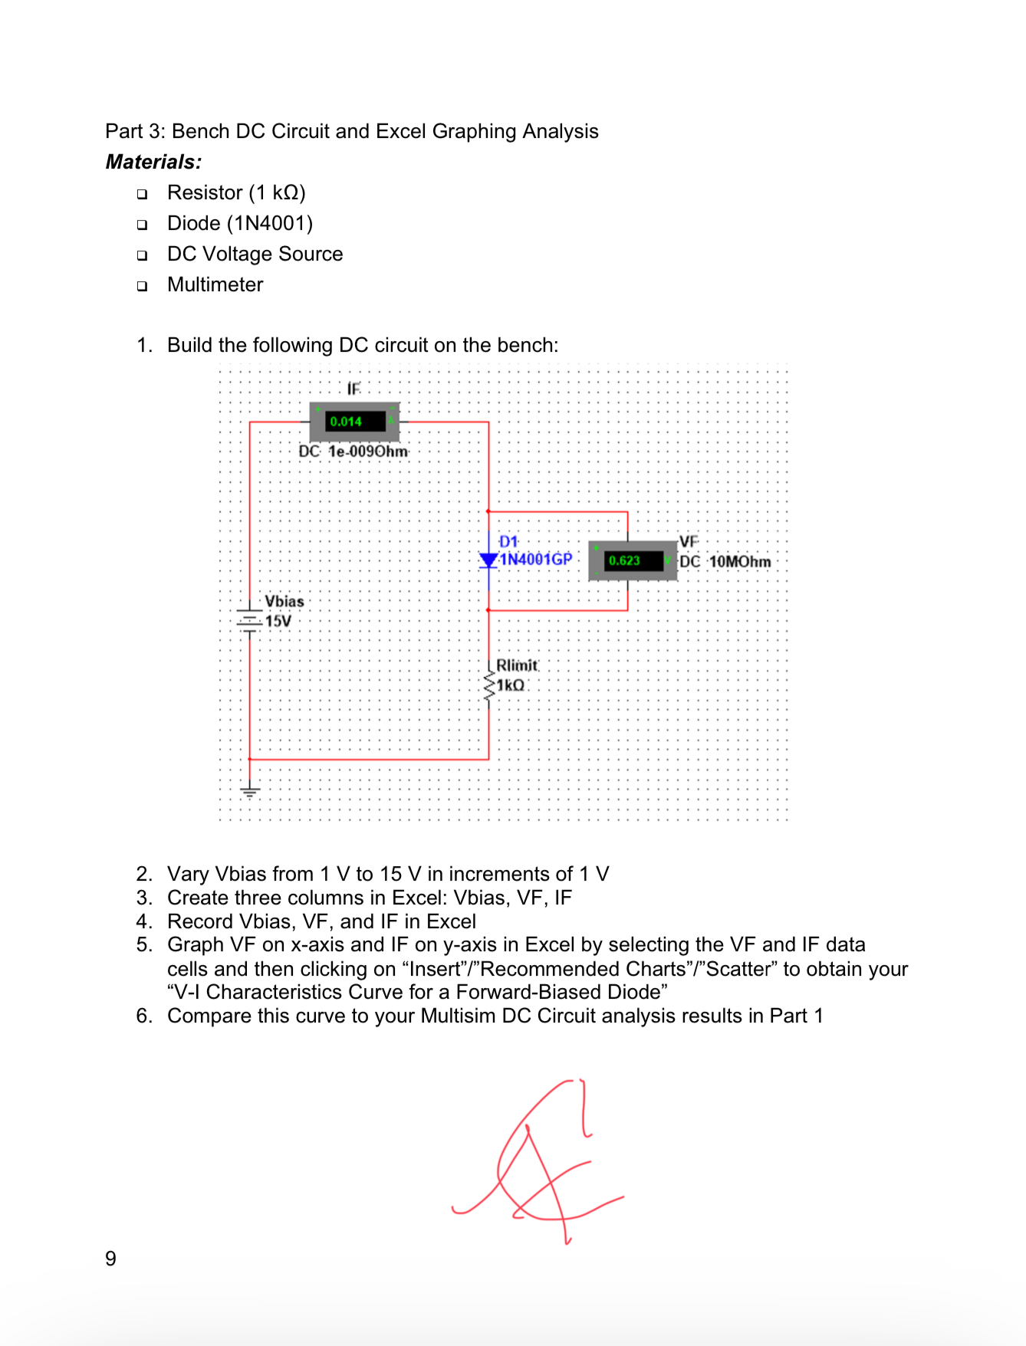

Figure - DC Circuit LA Approval

***Part 4 – Measuring the AC Circuit***

The final step for this lab is constructing the AC circuit on the bench, and using the practical oscilloscope equipment to measure resulting data.

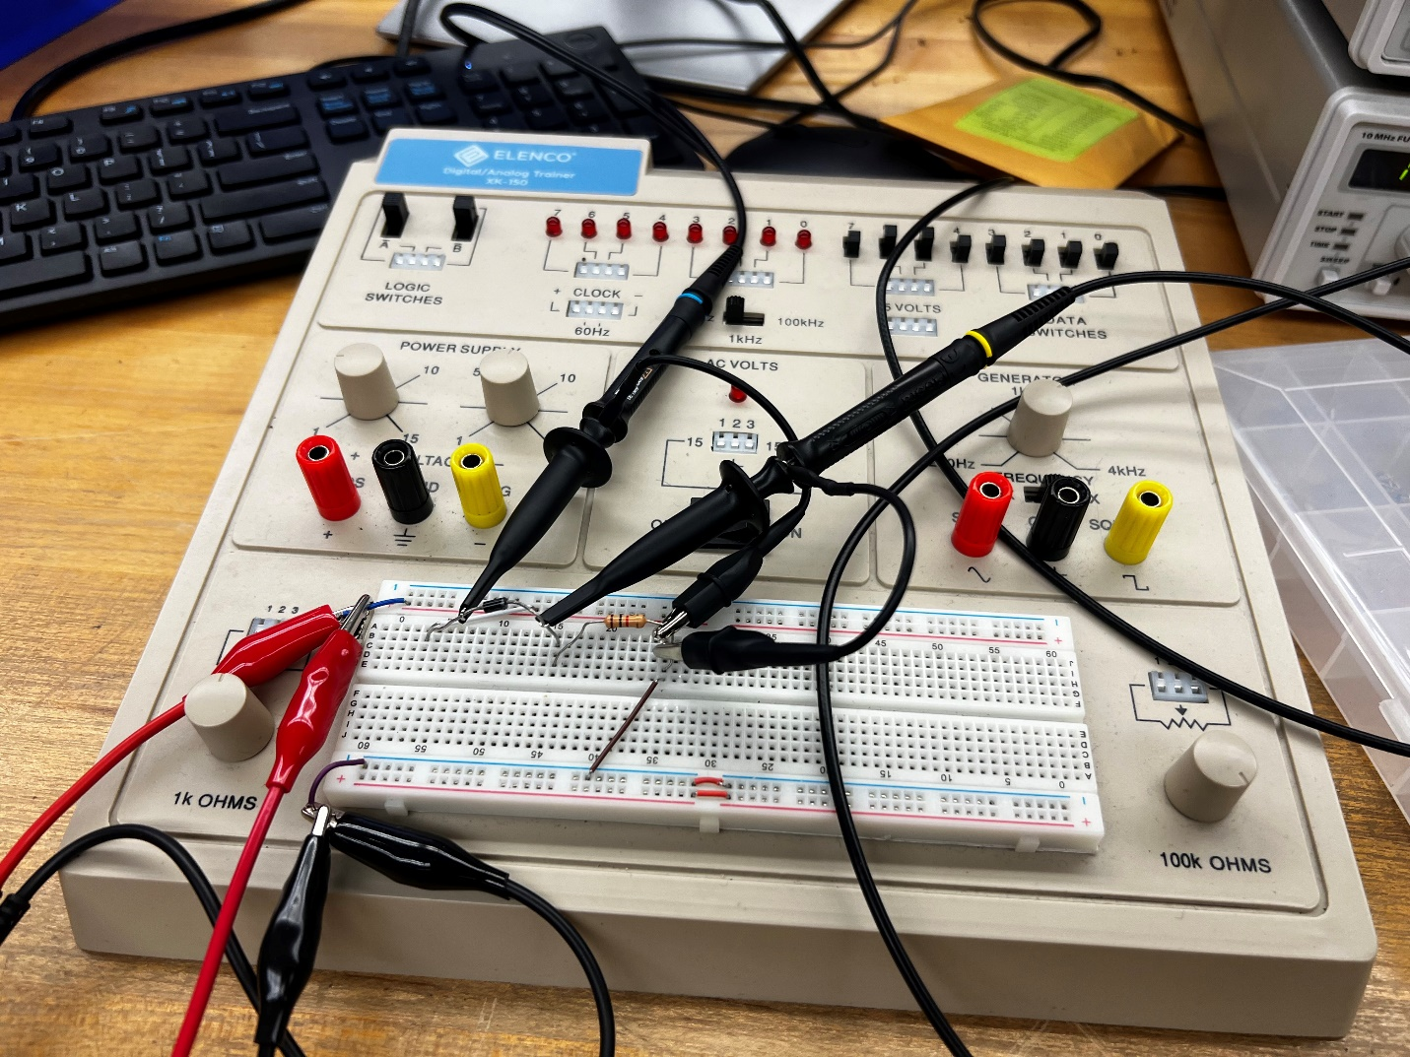

Figure - AC Circuit Constructed on Bench

Note here the placement of the oscilloscope probes. Channel 1 is connected to anode of the diode, and the cathode of the load resistor, and channel 2 is connected to the cathode of the diode, and the same cathode of the load resistor. Also of note are the DMM probes connected to the same nodes as the function generator, as we are measuring to find the VPP from the function generator. (Actually shown as Vrms on the DMM, but can be converted to VPP by using the following formula):

The oscilloscope result can be found in **Figure 7** below. Note the output is being shown in DC voltage, similar to our simulation result.

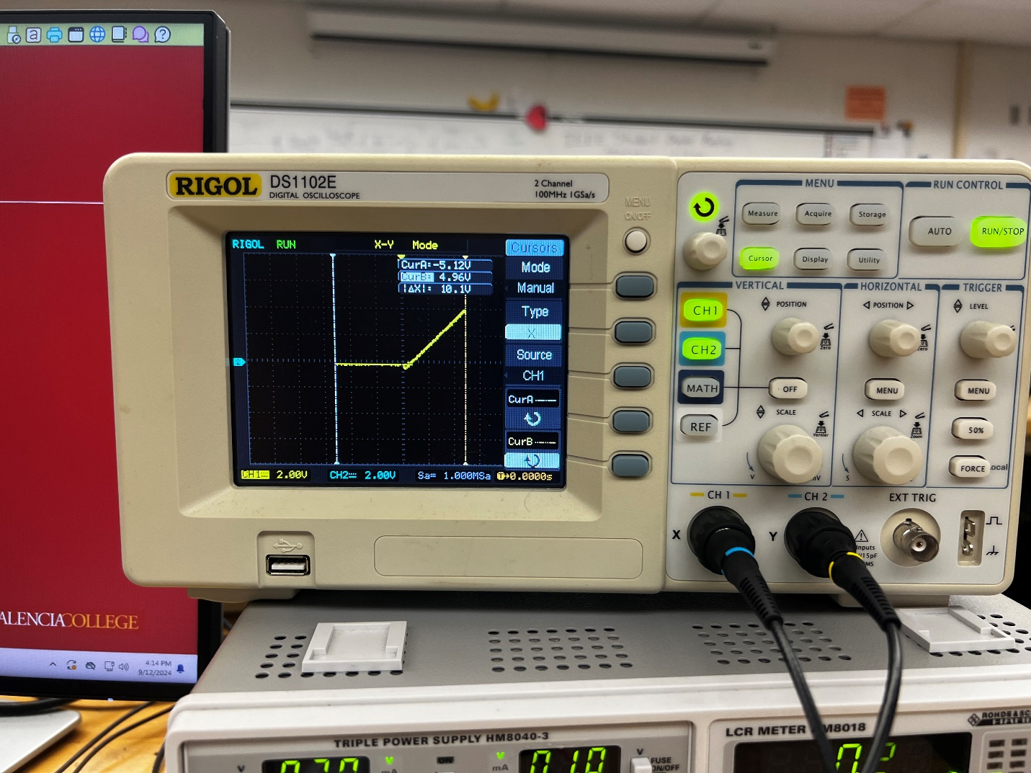

Figure - AC Sinusoidal Result Shown as DC Output

For the sake of continuity, shown below in **Figure 8** is the Function Generator and DMM interfaces while measuring the AC circuit signal. Note the Function Generator set to frequency of 1000Hz to match our simulation boundaries.

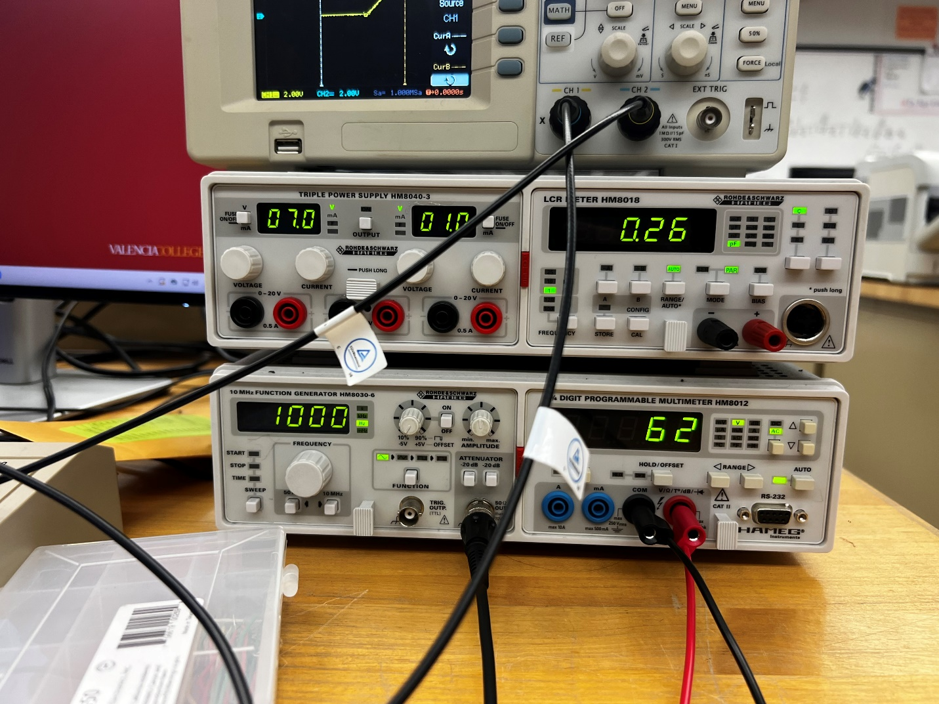

Figure - Function Generator and DMM for AC Circuit

Finally, once again, the instructor/lab assistant approval is given below in **Figure 9**.

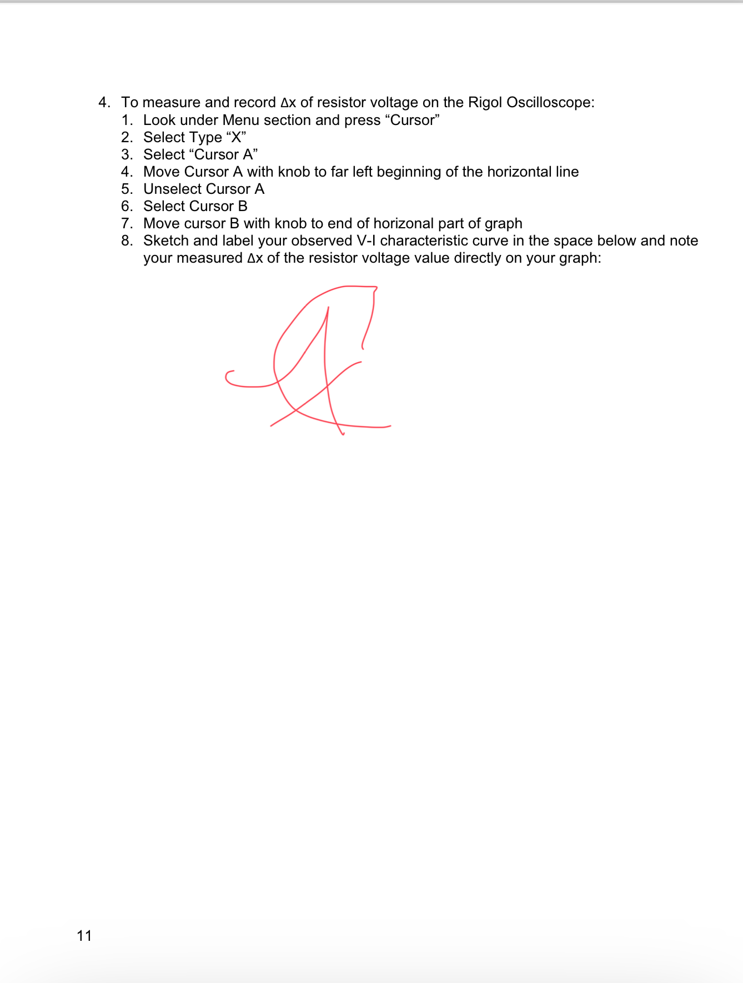

Figure - Part 2 LA Approval

#### Conclusion:

The lab objective of understanding and visualizing the V-I characteristics of a silicon diode was successfully met during the course of this lab. This is because, when analyzing our simulation versus our bench data, there is a clear similarity in the trend of the characteristic curve. While there is a slight deviation in forward voltage, this can be explained by a difference in practical versus ideal resistor values. Here we can learn that, similar to the behavior exhibited by Ohm’s Law, The relationship between voltage and current in a silicon diode, and presumably any semiconductor, is directly proportionate. If this lab were to be conducted again, I believe it would’ve been beneficial to produce additional circuits with more components, such as a capacitor, inductor, or even simply more resistors, to help further prove the original theorem and object of the lab.